**EXPERIMENT 2**

**AIM:**

**A. Design a web page using CSS Font and text properties.**

**B. Design a webpage using background properties**

**CODE:**

**HTML Code:**

<!DOCTYPE html>

<html lang="en">

<head>

    <meta charset="UTF-8">

    <meta name="viewport" content="width=device-width, initial-scale=1.0">

    <title>Font & Text Properties</title>

    <link rel="stylesheet" href="Fontandtext.css">

</head>

<body>

    <div class="container">

        <h1 class="title">Font Showcase</h1>

        <div class="font-box">

            <h2>Arial</h2>

            <p class="font-sample" style="font-family: 'Arial', sans-serif;">The quick brown fox jumps over the lazy dog.</p>

        </div>

        <div class="font-box">

            <h2>Verdana</h2>

            <p class="font-sample" style="font-family: 'Verdana', sans-serif;">The quick brown fox jumps over the lazy dog.</p>

        </div>

        <div class="font-box">

            <h2>Georgia</h2>

            <p class="font-sample" style="font-family: 'Georgia', serif;">The quick brown fox jumps over the lazy dog.</p>

        </div>

        <div class="font-box">

            <h2>Times New Roman</h2>

            <p class="font-sample" style="font-family: 'Times New Roman', serif;">The quick brown fox jumps over the lazy dog.</p>

        </div>

    </div>

</body>

</html>

**CSS Code:**

/* General body styles */

body {

    margin: 0;

    font-family: Arial, sans-serif;

    background-color: #f4f4f4;

    color: #333;

    text-align: center;

}

/* Container for centering content */

.container {

    max-width: 800px;

    margin: 20px auto;

    padding: 20px;

}

/* Heading styles */

.title {

    font-family: 'Courier New', Courier, monospace; /* Changed font for the title */

    font-size: 2.5em;

    color: #2c3e50;

    margin-bottom: 20px;

}

/* Style for each font box */

.font-box {

    background-color: #fff;

    border: 1px solid #ddd;

    border-radius: 8px;

    padding: 20px;

    margin: 20px 0;

    box-shadow: 0 2px 4px rgba(0, 0, 0, 0.1);

}

/* Font name heading style */

.font-box h2 {

    font-size: 1.8em;

    color: #2c3e50;

    margin-top: 0;

    margin-bottom: 10px;

}

/* Sample text style */

.font-sample {

    font-size: 1.2em;

    line-height: 1.5;

    margin: 0;

    padding: 10px;

    border: 1px solid #ddd;

    border-radius: 4px;

    background-color: #fafafa;

}

**OUTPUT:**

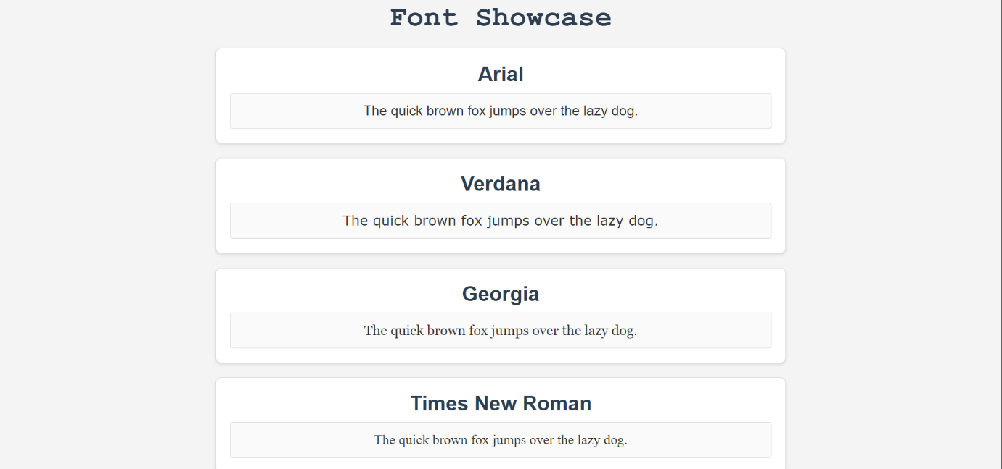

**B. Design a webpage with background properties**

**CODE:**

**HTML Code:**

<!DOCTYPE html>

<html lang="en">

<head>

    <meta charset="UTF-8">

    <meta name="viewport" content="width=device-width, initial-scale=1.0">

    <title>Buy Games</title>

    <link rel="stylesheet" href="Backgroundproperties.css">

</head>

<body>

    <div class="container">

        <h1>Buy Your Favorite Games</h1>

        <div class="game-boxes">

            <div class="game-box" style="background-image: url('re4r');">

                <h2>Resident Evil 4 Remake</h2>

            </div>

            <div class="game-box" style="background-image: url('re8');">

                <h2>Resident Evil 8: Village</h2>

            </div>

            <div class="game-box" style="background-image: url('gowr');">

                <h2>God of War Ragnarok</h2>

            </div>

            <div class="game-box" style="background-image: url('dl');">

                <h2>Dying Light</h2>

            </div>

        </div>

    </div>

</body>

</html>

**CSS Code:**

body {

    margin: 0;

    padding: 0;

    background-color: #2c2c2c; /* Dark but not too dark background color */

    font-family: Arial, sans-serif;

    color: #fff;

}

.container {

    max-width: 1200px;

    margin: 0 auto;

    padding: 20px;

}

h1 {

    text-align: center;

    margin-bottom: 20px;

    font-size: 2.5em;

    color: #e0e0e0;

}

.game-boxes {

    display: flex;

    justify-content: space-around;

    flex-wrap: wrap;

    gap: 20px;

}

.game-box {

    position: relative;

    width: 300px;

    height: 200px;

    overflow: hidden;

    border-radius: 10px;

    box-shadow: 0 4px 8px rgba(0, 0, 0, 0.5);

    background-size: cover;

    background-position: center;

}

.game-box h2 {

    position: absolute;

    bottom: 10px;

    left: 10px;

    margin: 0;

    font-size: 1.5em;

    color: #fff; /* White text for contrast */

    padding: 10px;

    border-radius: 5px;

    /* Transparent background */

    background: rgba(0, 0, 0, 0);

}

**OUTPUT:**



**CONCLUSION: Hence, we have successfully implemented a web page with CSS and text properties and a webpage with background properties.**